**IBM MQ**

1. Login to the OpenShit Console with the provided URL. Once logged in click **OperatorHub** under **Operators** menu.

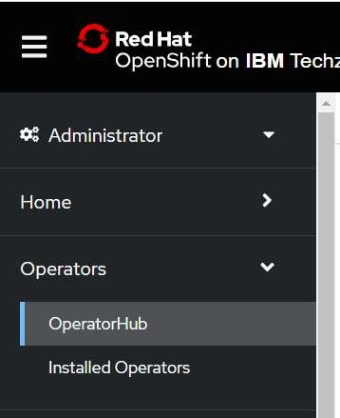

1. In the operator hub search for the tile **IBM MQ** and click on it.

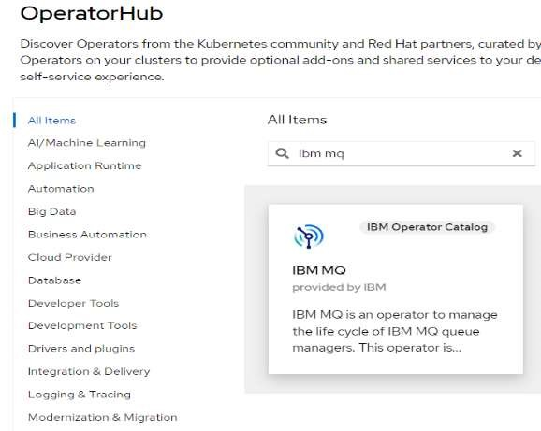

1. Read the document in the window and click on the **install** button.

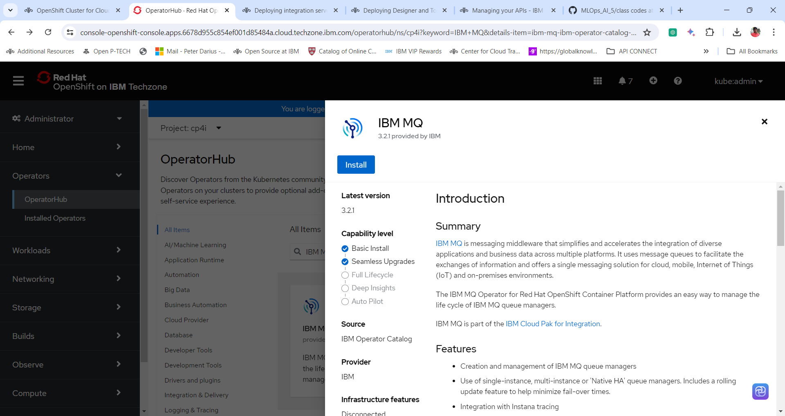

1. In next window select the **update channel** = **2.0**

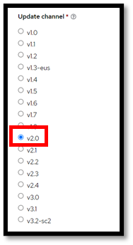

1. Select the Following

**Installation Mode = All Namespace mode**

**Namespace = Openshift-operators**

**Update Approval = Automatic**

**Click Install**

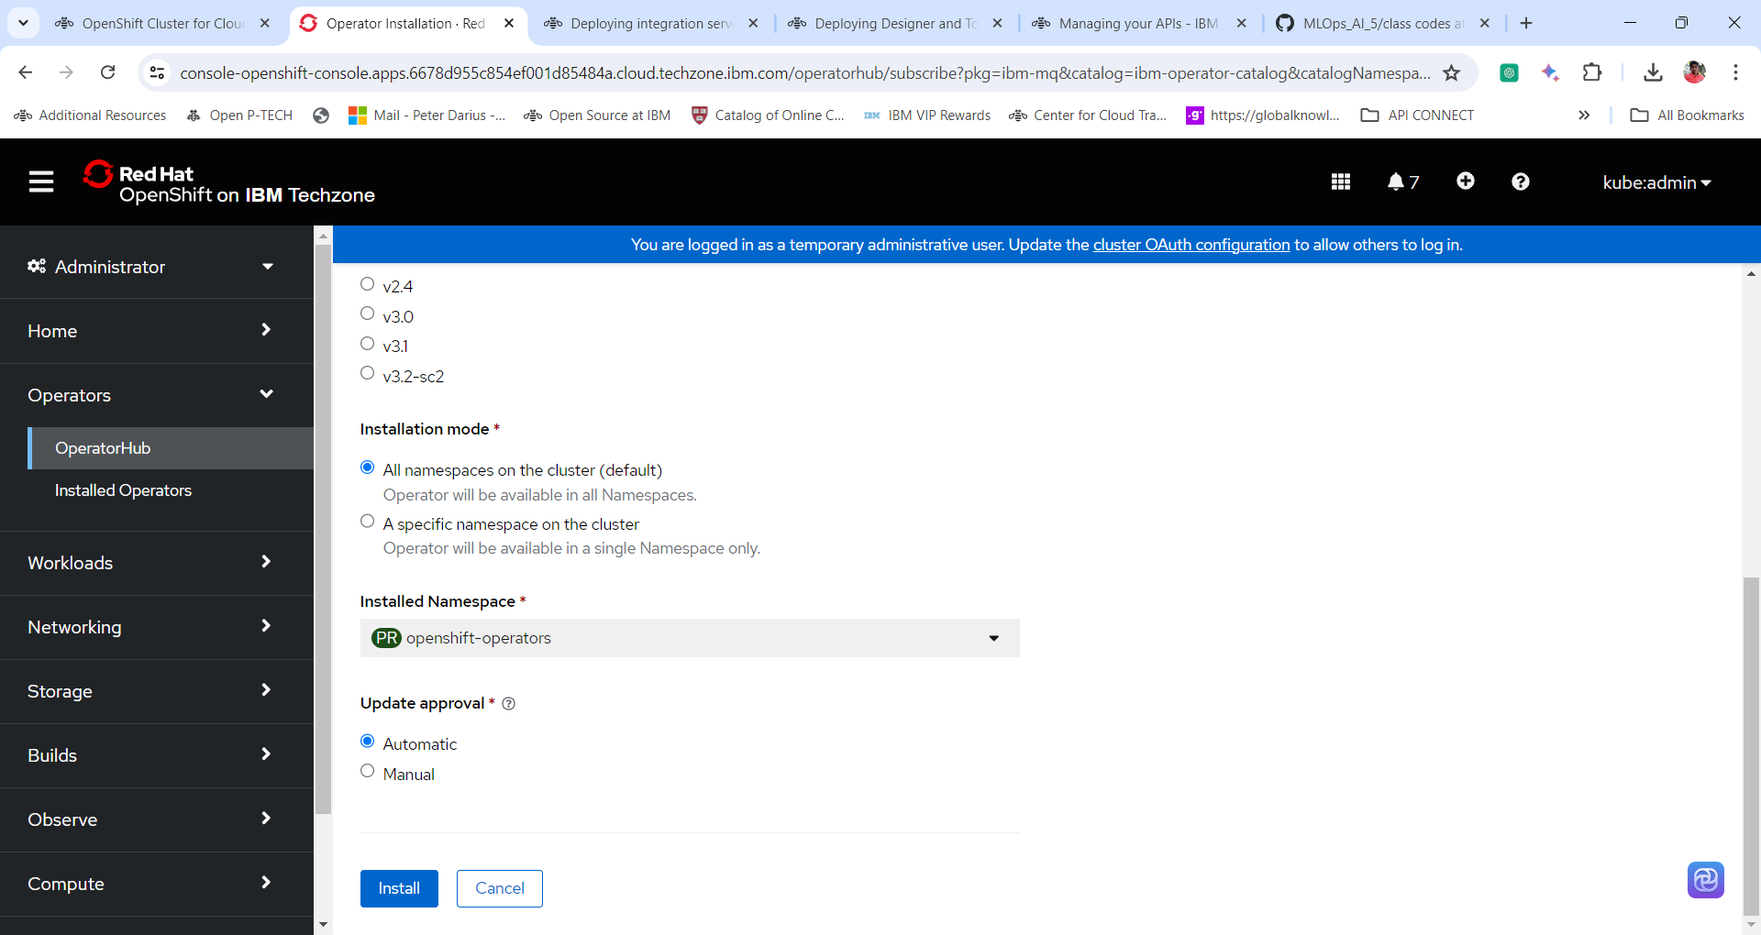

1. The Openshit Container Platform starts to install the operator. Wait for the installation to complete successfully.

1. Once the IBM MQ operator is installed and ready to use click **view operator** to view the details of the IBM MQ Operator.

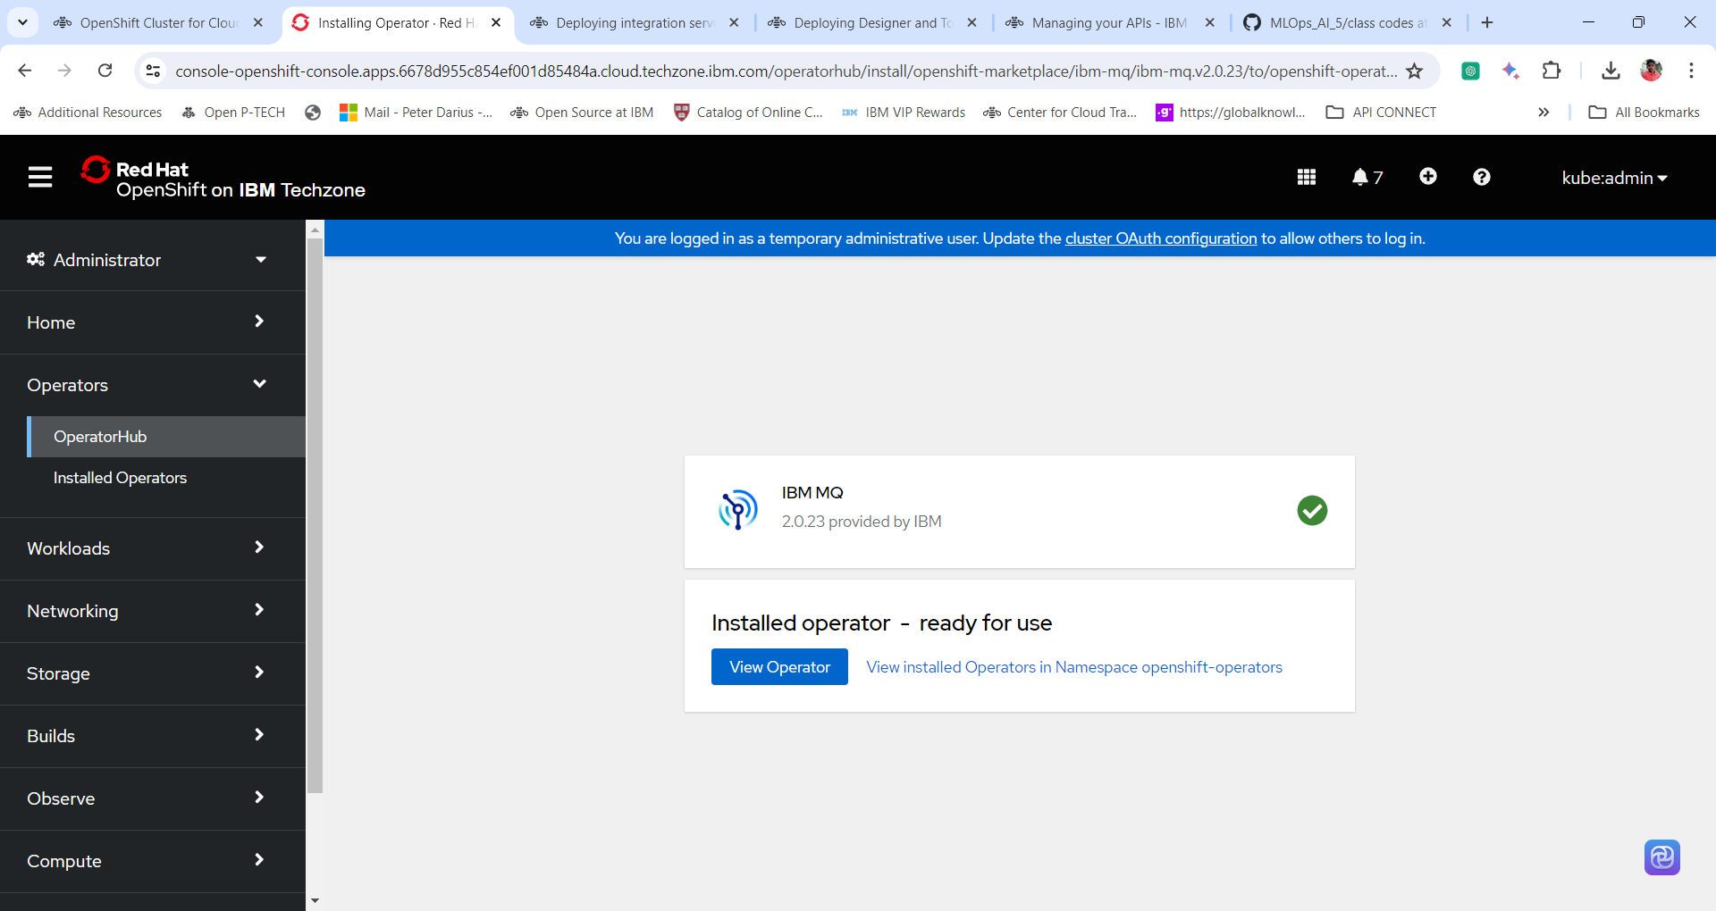

1. Go through the Details of the operator.

